**Challenge 1: Basic tools**

1. Import the project to netbeans or eclipse. This project is created in netbeans 8.0.2
2. Run tomcat using tomcat run jar

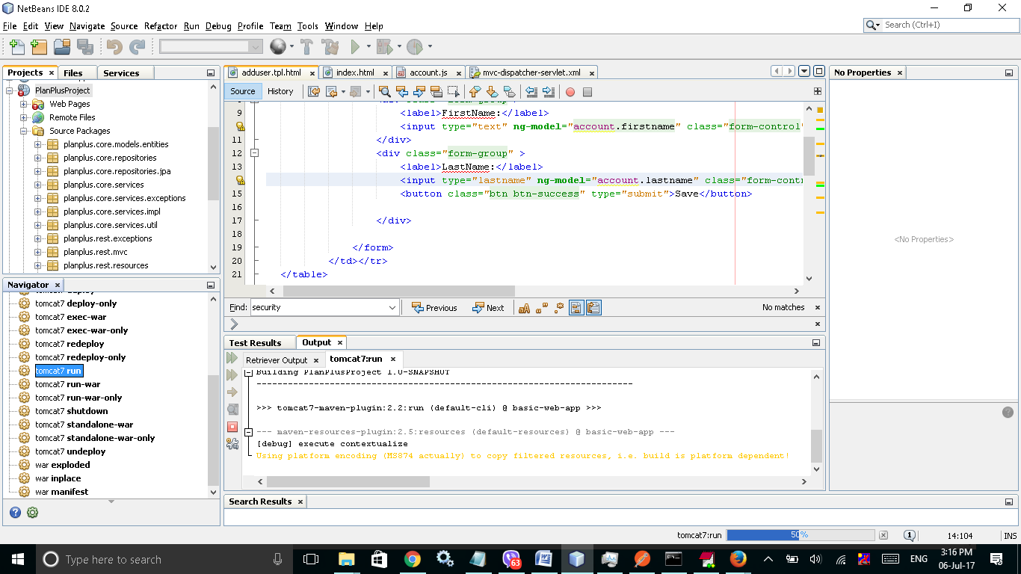

**Challenge 2: A simple web page  
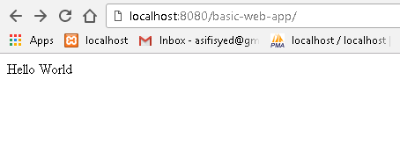**

**However, This link is no longer available due to back end implementation**

1. **Challenge 3: Build the back-end.  
   Spring URL display JSON.**

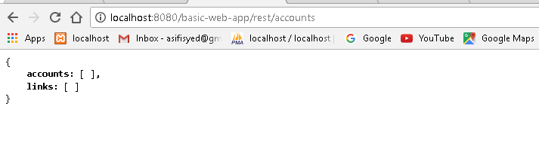

1. Locate URL to <http://localhost:8080/basic-web-app/app/index.html>

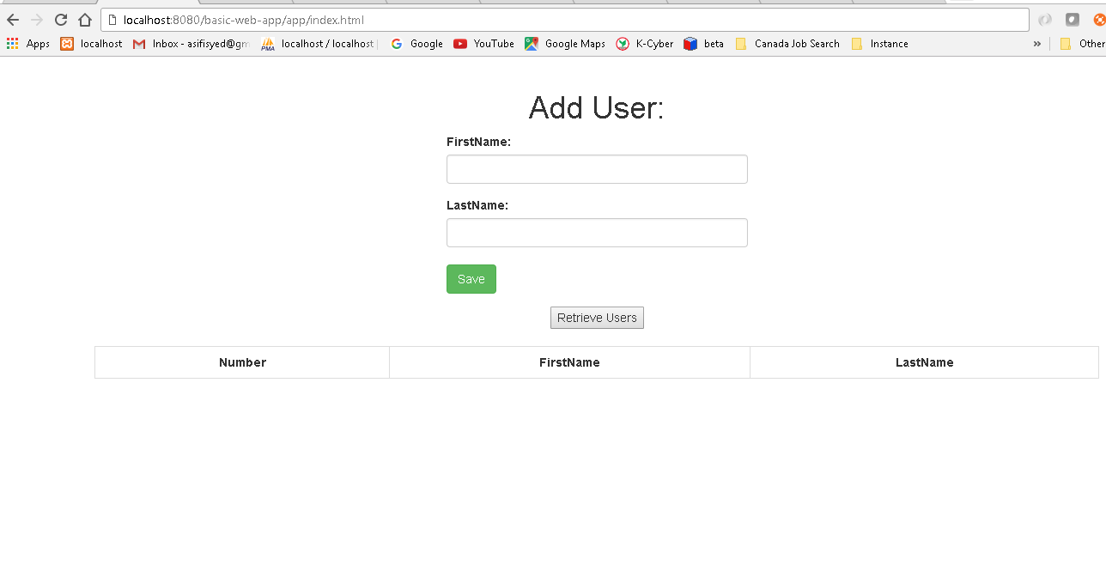

1. When run Tomcat first time database is empty
2. Add user. On success user will receive Add user successfully message otherwise Error adding user message will be displayed as alert.  
   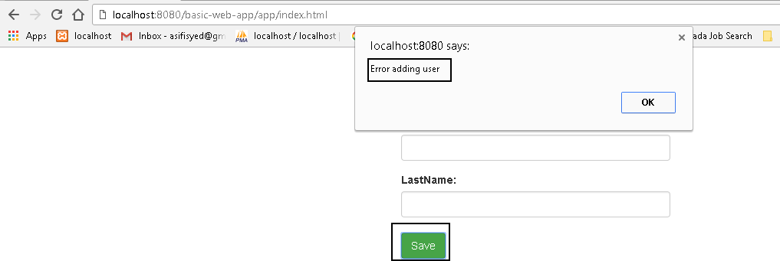

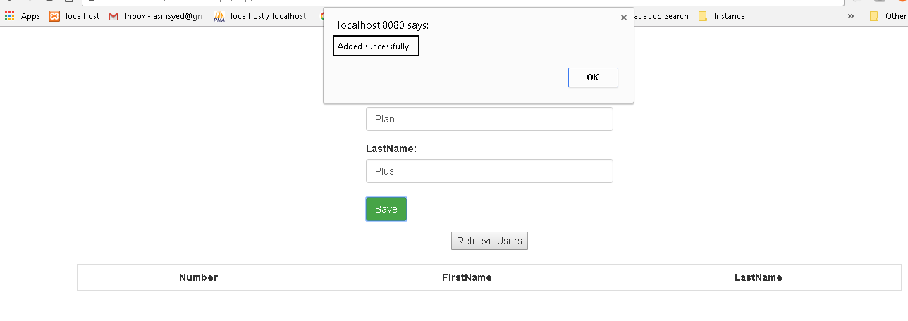

1. Click Retrieve user.  
   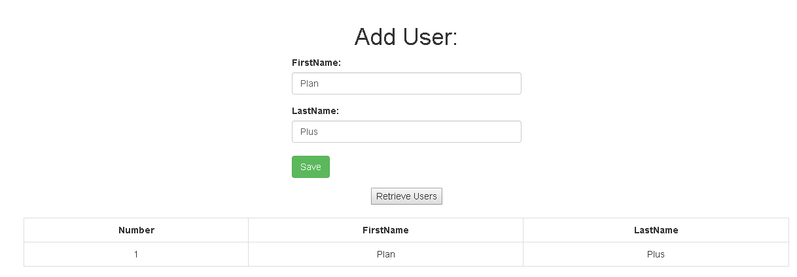

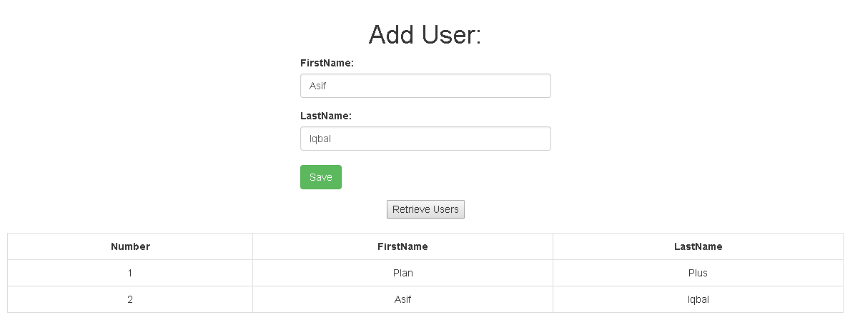

1. Database: Hibernate h2 in-memory database is used in order to facilitate run the program in quick time.   
   Configuration is available in resources/spring/business-config.xml  
   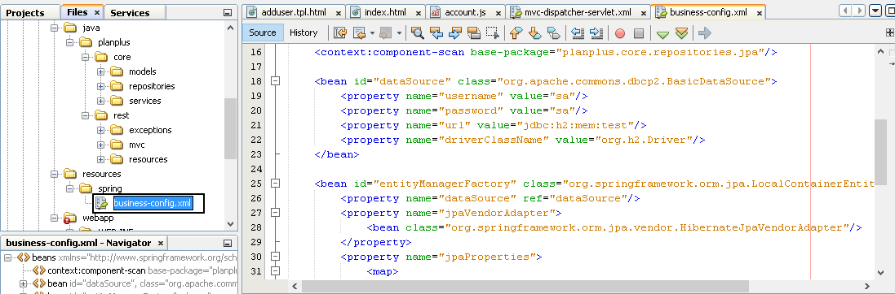
2. Unit Test  
   MVC Test: Junit and Mockito Test has performed in order to verify service request. MockMvc object is used to test Controller intercept.

JPA Test: AccountRepo test confirms services are working properly.

1. Postman Web Service client confirms get and post are functioning properly.  
   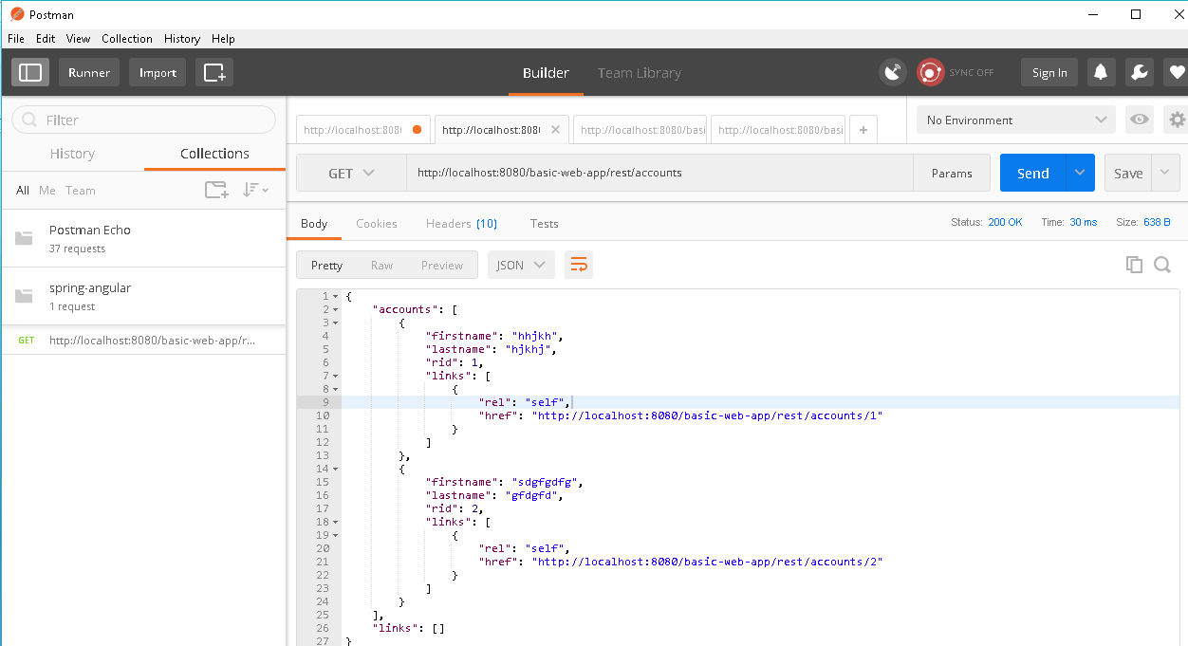

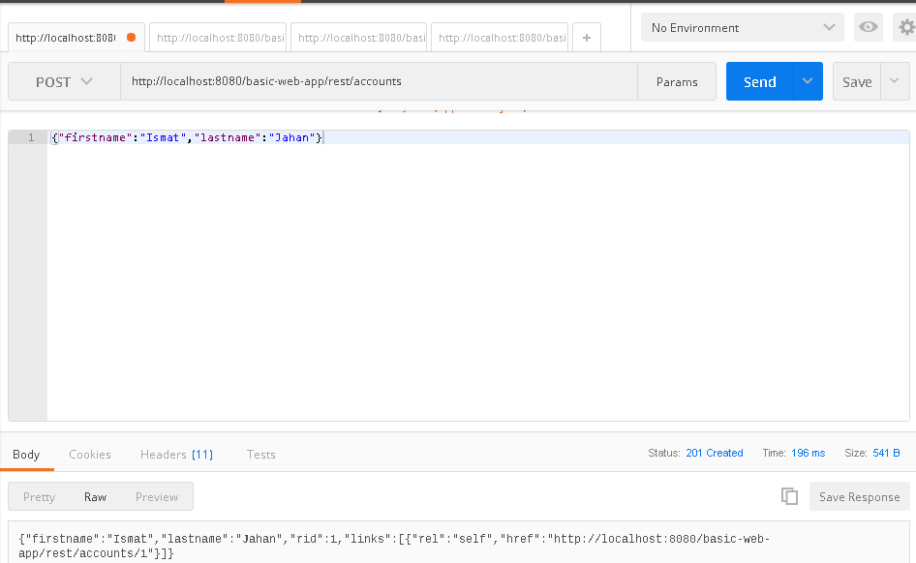

1. Angular JS is used as web application. Application server running.   
   